**2022 BCHS PIRATE ATHLETIC HALL OF FAME INDUCTEES**

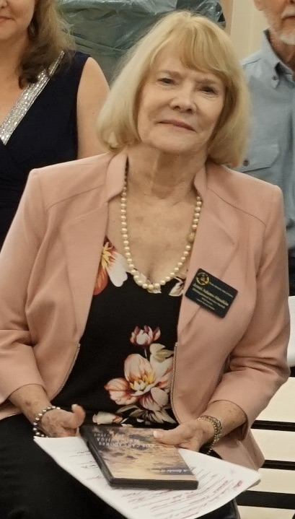

Jenni Adams - Sinaikin ’62 Distinguished Service

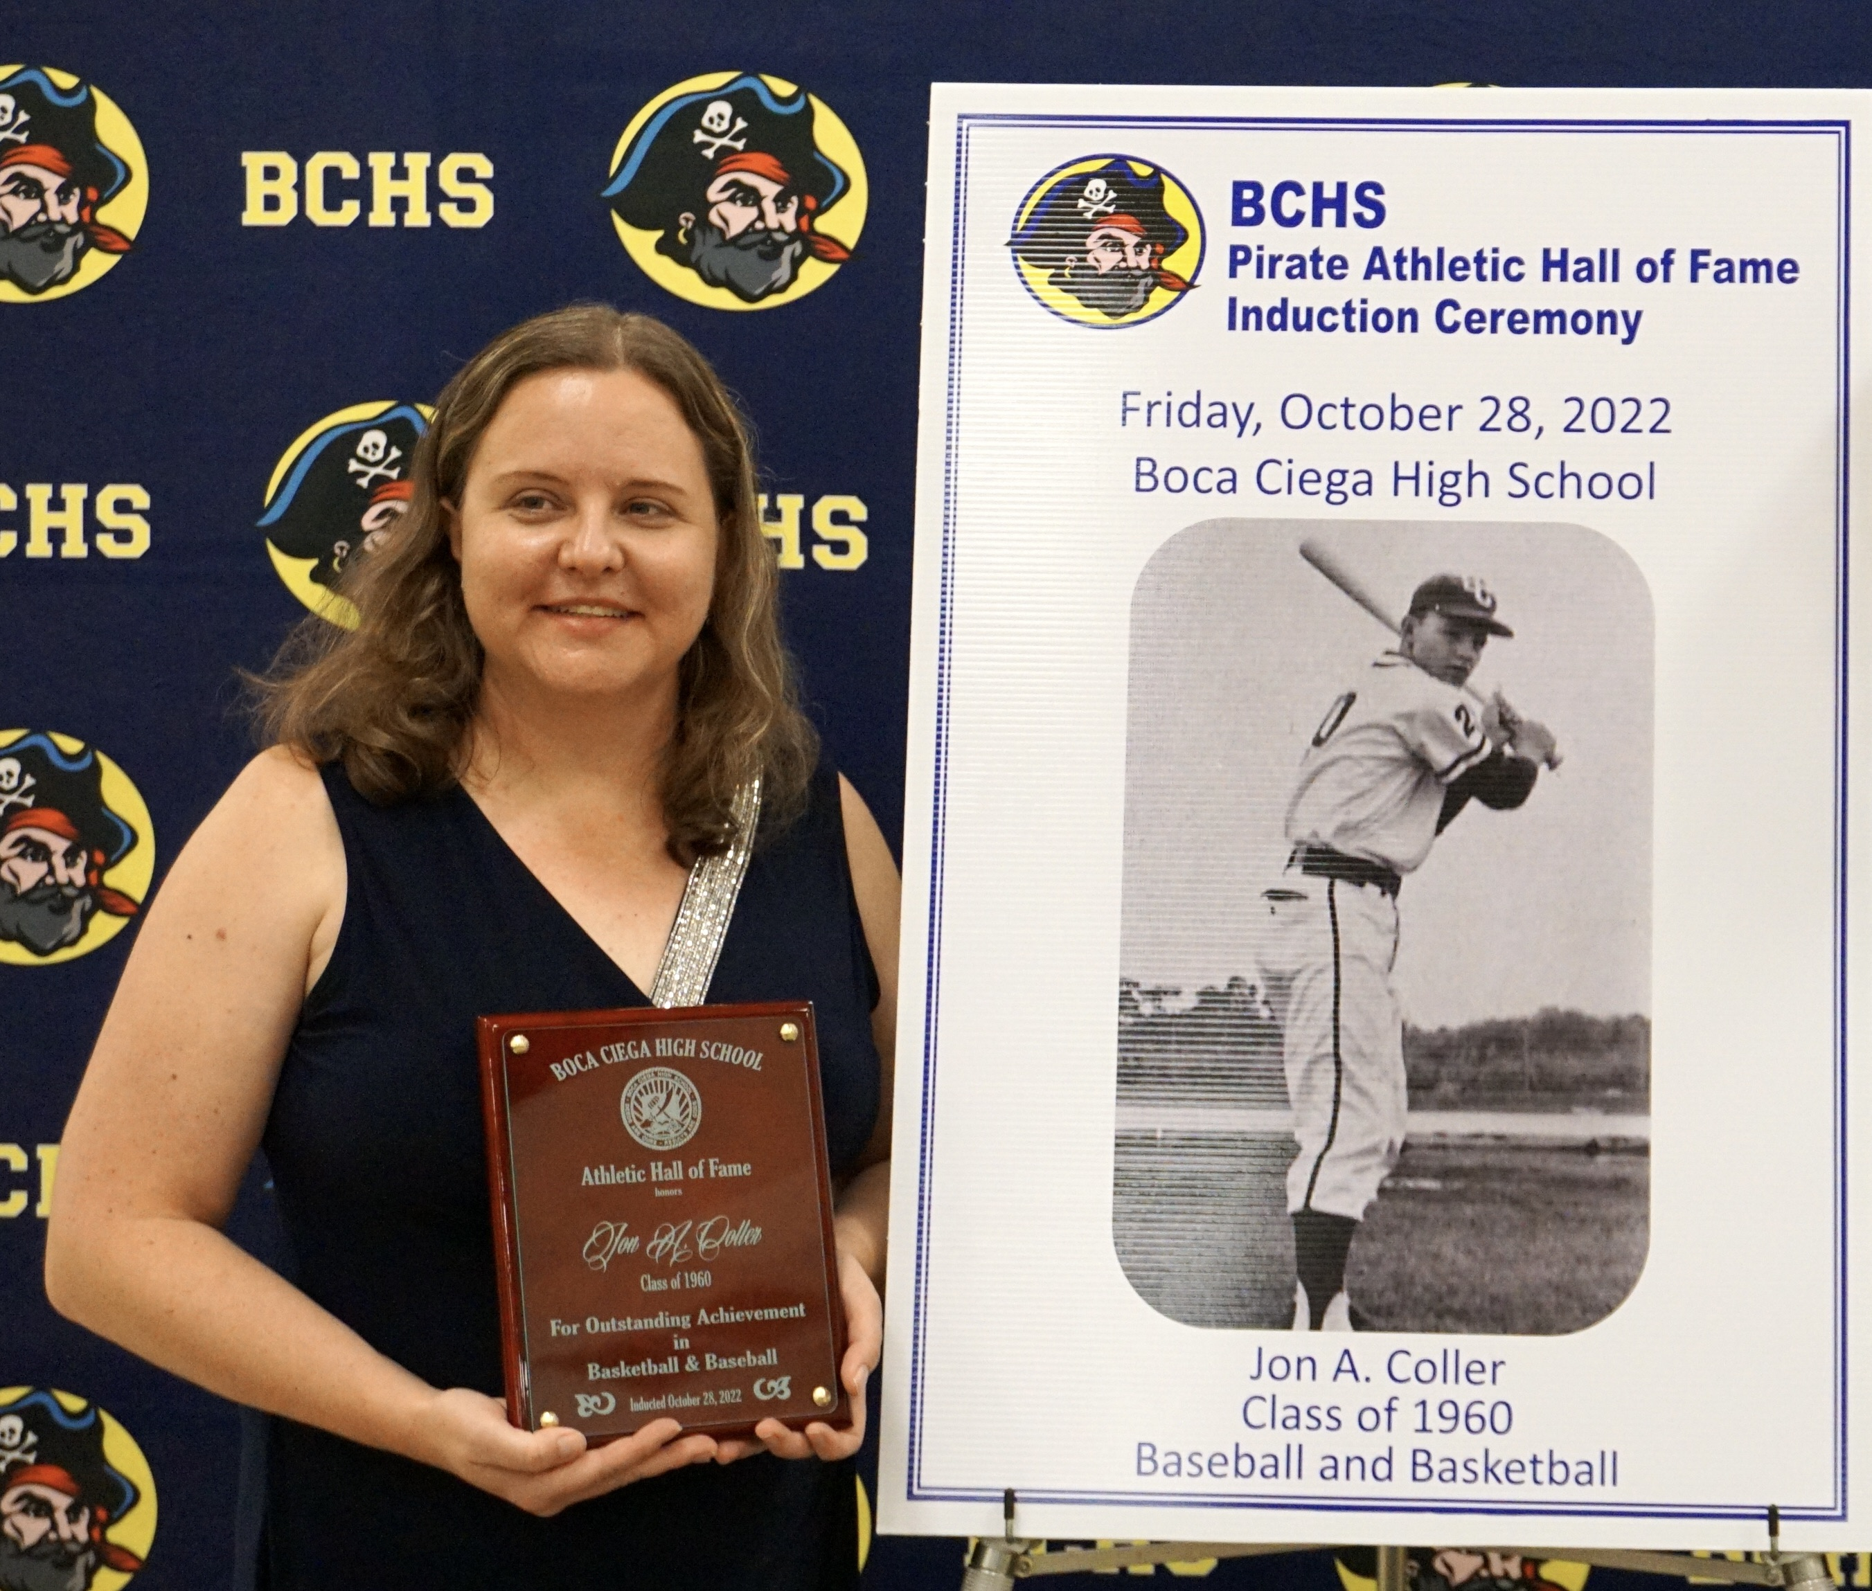

JON A. COLLER 1960 (SALENA COLLER - DAUGHTER) POSTHUMOUSLY FOR BASKETBALL/BASEBALL

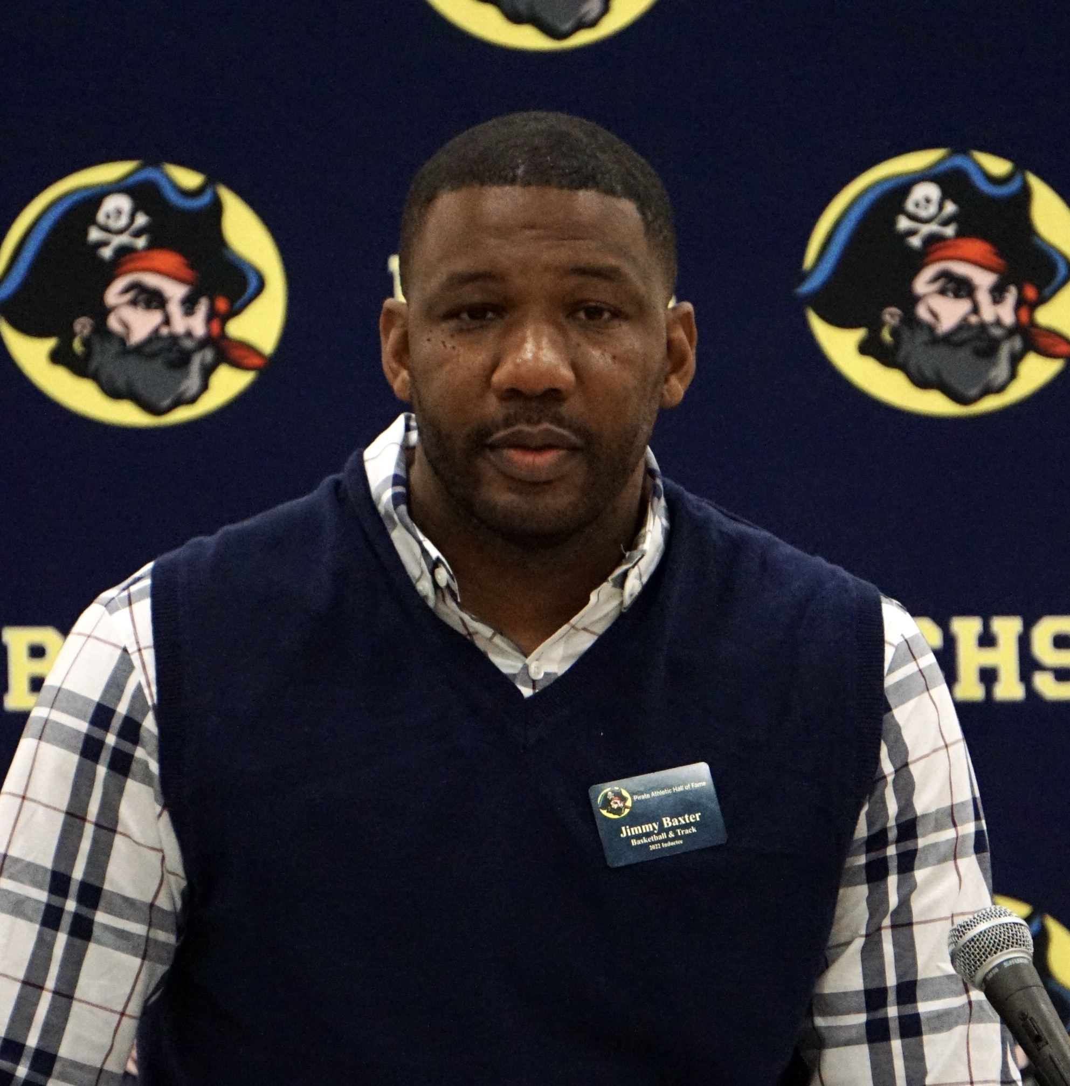

JIMMY BAXTER, 2000 BASKETBALL/TRACK

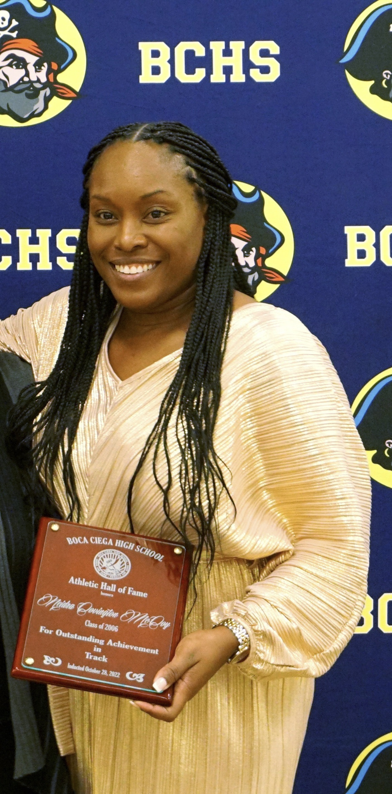

NEIDRA COVINGTON MCCOY 2006 Track/Field

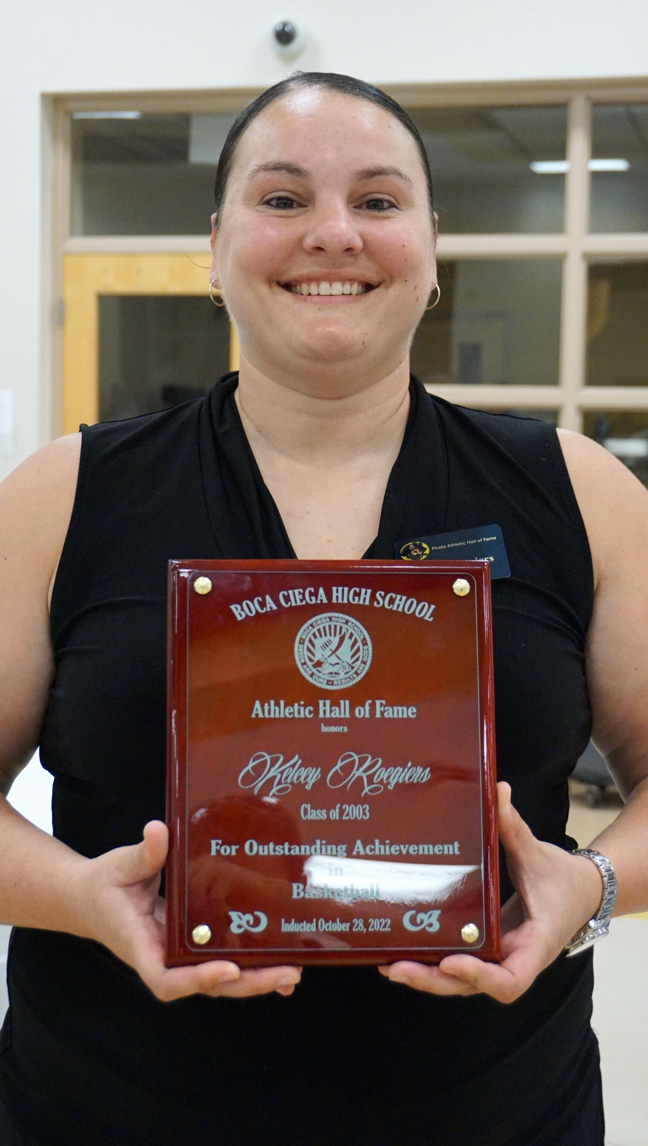

KELCEY ROEGIERS 2003 GIRLS BASKETBALL

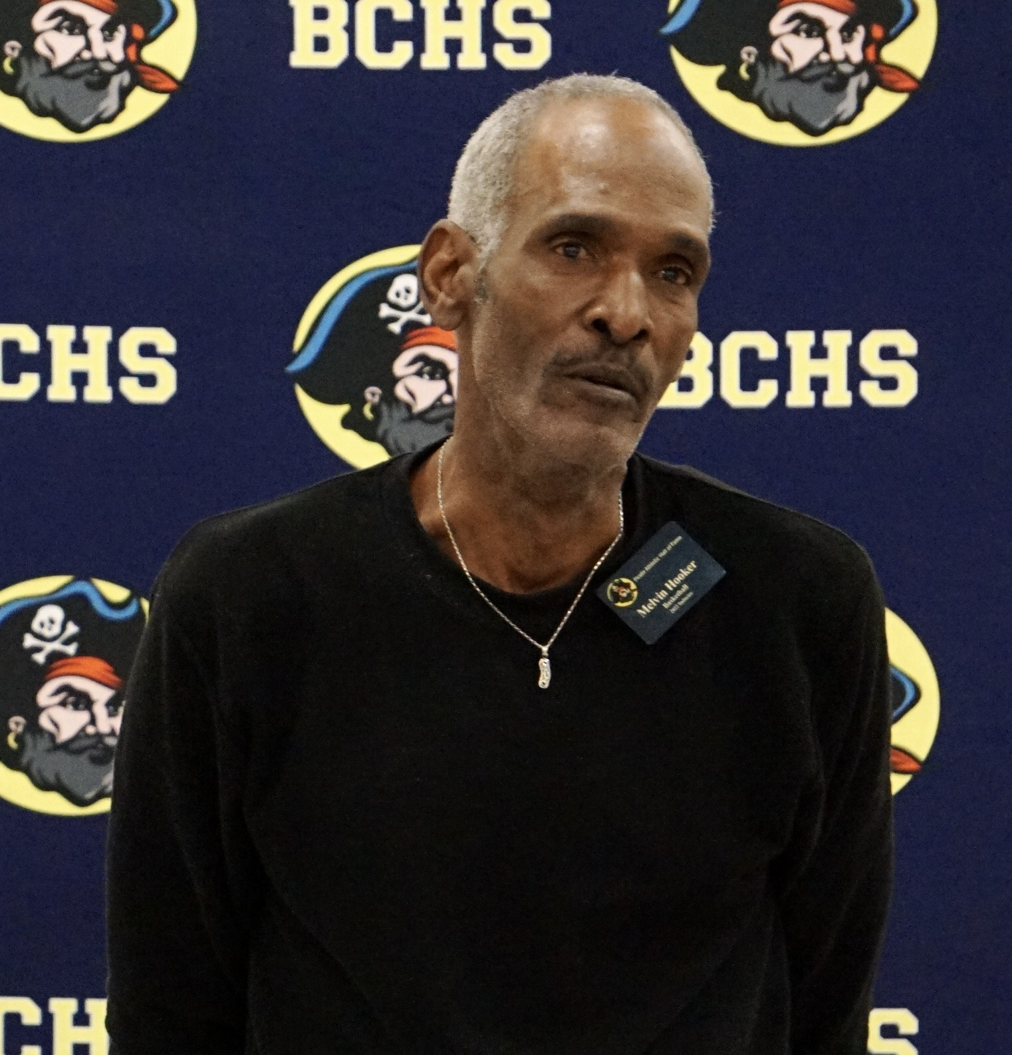

MELVIN HOOKER 1973 BASKETBALL